**PROJET HTML**

**Professeur : Jean marie PREIRA**

**Etudiants :**

**Alfi THIAM**

**Masseyni THIAM**

**Année académique : 2022/2023**

**PLAN**

**Projet**

1. **Template**
2. **Feuille de style**
3. **Lien du site web**
4. **Captures d’écrans**

**Conclusion**

1. **Projet HTML**

**Notre projet est un site web mettant l’accent sur les merveilles du monde. Il s’agit des célèbres :**

***-DES PYRAMIDES D’EGYPTE, LES DUNES DU SAHARA AU MAROC en AFRIQUE***

***-DE LA TOUR EIFFEIL, LA GRECE et L’ITALIE en EUROPE***

***-LA MAISON BLANCHE, WALK OF FAME HOLLYWOOD et TIMES SQUARE aux USA***

***-MURAILLE DE CHINE, JAPON et MALAISE***

**IL est réalisé sur six (6) pages html.**

**La première nommée index.html renvoie à la page d’accueil du site web. Les autres pages Afrique.html, Europe.html, Amerique.html, Asie.html et Oceanie.html renvoient chacune à sa page spécifique. L’accès à ses pages est possible à partir de la page d’accueil grâce aux liens intégrés dans les images et au menu déroulant présent sur celle-ci. Ces sites ont été choisis pour divers raisons leur étant propres :**

* **L’AFRIQUE :**

**Si vous avez planifié un voyage en Afrique et vous êtes à la recherche de beaux endroits à visiter, jetez un coup d’œil à notre sélection. L’Afrique n’est pas connue seulement pour être le deuxième continent le plus grand et plus peuplé du monde. Sa célébrité est due également aux nombreuses curiosités impressionnantes, préservées depuis des siècles. Tous les pays africains ont leur propre position stratégique et offrent toutes sortes d’activités et de visites incontournables.**

* **L’EUROPE :**

**Toute l'Europe regorge de paysages brillant par leur beauté. Même l'environnement urbain a son propre attrait. Vous serez émerveillé par la beauté qui vous entoure, où que vos aventures européennes vous mènent. Que ce soit dans les grandes métropoles Européennes ou bien dans les magnifiques petits villages de Provence.**

* **L’AMERIQUE :**

**Les USA sont assurément un pays à découvrir, tant à la fois pour voir un match des Mets que le Grand Canyon, pour découvrir le vie sauvage des Rocheuses ou la vie tumultueuse de Las Vegas, tant pour déguster un hot dog que pour passer sa semaine à Disney World.**

* **L’ASIE :**

**Des traditions ancestrales encore bien vivantes, de nombreuses religions et de multiples ethnies font de l'Asie une région riche en cultures et en traditions. Le mode de vie souvent bien différent du nôtre est une source constante de fascination. Et même si les villes sont désormais modernes, en partie du moins, le mode de vie à la campagne n'a souvent guère changé depuis des générations.**

* **L’OCEANIE :**

**C'est la région par excellence des plages de sable blanc, des cocotiers balancés par la brise, des récifs coralliens et des îles volcaniques émergeant au milieu des eaux azurées.**

1. ***TEMPLATE***

**Les pages du projet ont été réalisés selon le Template suivant :**

|  |
| --- |
| **BODY** |
| **MENU** |
| **PRINCIPAL** |

1. ***FEUILLE DE STYLE***
2. ***Index.html***

|  |  |
| --- | --- |
| **selecteur** | **caractéristiques** |
| **diapo** | flex: 1 0 auto;  height: fit-content;  /*border: 3px solid rgb(255, 255, 255);*/  background-image: url(https://th.bing.com/th/id/R.546ced301668d2d5834a7013f43bfd2f?rik=698JBVb0dUKHzA&pid=ImgRaw&r=0);  background-size: cover;  -webkit-animation-name: diapo;  -webkit-animation-duration: 20s;  -webkit-animation-timing-function: linear;  -webkit-animation-iteration-count: infinite;  -webkit-animation-direction: normal;  -moz-animation-name: diapo;  -moz-animation-duration: 20s;  -moz-animation-timing-function: linear;  -moz-animation-iteration-count: infinite;  -moz-animation-direction: normal;  animation-name: diapo;  animation-duration: 20s;  animation-timing-function: linear;  animation-iteration-count: infinite;  animation-direction: normal; |
| **@-webkit-keyframes diapo** | 0%{background-image: url(https://images.hdqwalls.com/download/burj-al-arab-dm-5120x2880.jpg);background-size: cover}  25%{background-image: url(https://th.bing.com/th/id/R.c569f1ddfb0e59a20ad71af647e17ef9?rik=KM%2fYZ6PfuZIgTQ&pid=ImgRaw&r=0);background-size: cover}  50%{background-image: url(https://images.hdqwalls.com/download/sunset-over-manhattan-bridge-8u-3840x2400.jpg);background-size: cover}  75%{background-image: url(https://images.hdqwalls.com/download/hot-air-balloons-sky-fr-3840x2400.jpg);background-size: cover} |
| **@-moz-keyframes diapo** | 0%{background-image: url(https://images.hdqwalls.com/download/burj-al-arab-dm-5120x2880.jpg);background-size: cover}  25%{background-image: url(https://th.bing.com/th/id/R.c569f1ddfb0e59a20ad71af647e17ef9?rik=KM%2fYZ6PfuZIgTQ&pid=ImgRaw&r=0);background-size: cover}  50%{background-image: url(https://images.hdqwalls.com/download/sunset-over-manhattan-bridge-8u-3840x2400.jpg);background-size: cover}  75%{background-image: url(https://images.hdqwalls.com/download/hot-air-balloons-sky-fr-3840x2400.jpg);background-size: cover} |
| **@keyframes diapo** | 0%{background-image: url(https://images.hdqwalls.com/download/burj-al-arab-dm-5120x2880.jpg);background-size: cover}  25%{background-image: url(https://th.bing.com/th/id/R.c569f1ddfb0e59a20ad71af647e17ef9?rik=KM%2fYZ6PfuZIgTQ&pid=ImgRaw&r=0);background-size: cover}  50%{background-image: url(https://images.hdqwalls.com/download/sunset-over-manhattan-bridge-8u-3840x2400.jpg);background-size: cover}  75%{background-image: url(https://images.hdqwalls.com/download/hot-air-balloons-sky-fr-3840x2400.jpg);background-size: cover} |
| **principal** | color: azure;  background-size: 100%;  width: 1350px;  height: 100px;  margin-right: auto;  background-repeat: no-repeat;  display: inline-block;  background-size: 100% 100%;  padding-top: 15%; |
| **principal>#entete>h1** | font-size: 20px; |
| **principal>#entete>header** | margin-left: auto;  margin-right: auto; |
| **entete** | width: 1000px;  margin-left: 10%;  padding-left: 10%;  font-size: 70px;  color: rgb(23, 17, 28);  animation: typing-animation 2s steps(25);  white-space: nowrap;  overflow: hidden; |
| **@keyframes typing-animation** | from{ width: 0; } |
| **menu** | font-size: large ;  height: 70px;  width: 1500px;  background-color: white; |
| **menu ul>li** | font-size: 25px;  display: inline-block;  margin-left: 7%;  line-height: 70px;  padding-left: 30px;  padding-right: 30px;  color: brown;  } |
| **a** | text-decoration: none;  color: rgb(45, 7, 7); |
| **li :hover** | color: rgb(255, 77, 0);  background-size: 100px; |

1. ***Afrique.html :***

|  |  |
| --- | --- |
| **body** | background-size: 100% 100%; |
| **baniere** | background-image: url(https://i.pinimg.com/564x/2f/2a/d1/2f2ad1f3b59c7e0327358ee49aed708c.jpg);  background-repeat: no-repeat;  position: fixed;  -webkit-background-size: cover;  background-size: cover;  background-position: center center;  width: 100%;  height: 600px;  top: 100px; |
| **menu** | font-size: large ;  height: 70px;  width: 1520px;  background-color: aliceblue; |
| **menu ul>li** | font-size: 20px;  display: inline-block;  margin-left: 6%;  line-height: 40px;  padding-left: 30px;  padding-right: 30px;  color: rgb(100, 19, 19);  padding-top: 1%; |
| **li a:hover** | color: rgb(88, 217, 235); |
| **ul li a** | color: rgb(172, 58, 58);  text-decoration: none; |
| **EU** | color: white;  margin-top: 15%;  padding-left: 25%;  font-size: 120px;  display: block;  position: relative; |
| **contenu** | position: relative;  top: 600px;  background-image: url(https://i.pinimg.com/564x/f2/ba/9c/f2ba9c6b6dce981a3d830c4ae5850198.jpg);  background-size: cover;  background-repeat: no-repeat;  height: 2600px; |
| **imgP** | padding-right: 10%;  padding-top: 3%; |
| **imgbox .paris** | text-align: justify;  color: rgb(255, 255, 255);  float: left;  width: 45%;  height: 650px;  margin-right: 5%;  font-size: 45px;  padding-top: 1%; |
| **eiffel** | padding-left: 3%; |
| **grece** | margin-top: 5%; |
| **h1** | color: rgb(225, 197, 134);  font-size: 40px; |
| **Gr h1** | float: right;  padding-right: 20%; |
| **grece .Gr p** | text-align: justify;  color: rgb(44, 0, 74);  float: left;  width: 50%;  height: 500px;  margin-right: 5%;  font-size: 30px;  padding-top: 0%;  padding-left: 45%; |
| **diapo** | /*margin: 0 auto;*/  flex: 1 0 auto;  width: 200vh;  background-size: 40% 100%;  height: 700px;  /*border: 3px solid rgb(255, 255, 255);*/  background-repeat: no-repeat;  background-image: url(https://www.relations-publiques.pro/wp-content/uploads/2018/02/CP-MEMPHIS-TOUR-PYRAMIDES.jpg);    -webkit-animation-name: diapo;  -webkit-animation-duration: 30s;  -webkit-animation-timing-function: linear;  -webkit-animation-iteration-count: infinite;  -webkit-animation-direction: normal;  -moz-animation-name: diapo;  -moz-animation-duration: 30s;  -moz-animation-timing-function: linear;  -moz-animation-iteration-count: infinite;  -moz-animation-direction: normal;  animation-name: diapo;  animation-duration: 30s;  animation-timing-function: linear;  animation-iteration-count: infinite;  animation-direction: normal; |
| **@-webkit-keyframes diapo** | 0%{background-image: url(https://th.bing.com/th/id/OIP.CLE1MVmvb7XS5clVwUAtOAHaG2?pid=ImgDet&w=640&h=592&rs=1);}  25%{background-image: url(https://th.bing.com/th/id/R.7463992baa80a5857a4f269e6f0e886b?rik=upJWlk%2fX%2fwfDiQ&pid=ImgRaw&r=0);}  50%{background-image: url(https://ak.picdn.net/shutterstock/videos/1024420484/thumb/1.jpg);}  75%{background-image: url(https://th.bing.com/th/id/R.665a3326836ce00230d8004d58e695d8?rik=t0Mq6yEO%2fsjaVA&riu=http%3a%2f%2fvalerie1306.v.a.pic.centerblog.net%2f0n6s0k17.jpg&ehk=dvwtFg%2f8r1OXtI4M%2fcrjX889RthyIcOEaOnFRd3nDVU%3d&risl=&pid=ImgRaw&r=0);} |
| **@-moz-keyframes diapo** | 0%{background-image: url(https://th.bing.com/th/id/OIP.CLE1MVmvb7XS5clVwUAtOAHaG2?pid=ImgDet&w=640&h=592&rs=1);}  25%{background-image: url(https://th.bing.com/th/id/R.7463992baa80a5857a4f269e6f0e886b?rik=upJWlk%2fX%2fwfDiQ&pid=ImgRaw&r=0);}  50%{background-image: url(https://ak.picdn.net/shutterstock/videos/1024420484/thumb/1.jpg);}  75%{background-image: url(https://th.bing.com/th/id/R.665a3326836ce00230d8004d58e695d8?rik=t0Mq6yEO%2fsjaVA&riu=http%3a%2f%2fvalerie1306.v.a.pic.centerblog.net%2f0n6s0k17.jpg&ehk=dvwtFg%2f8r1OXtI4M%2fcrjX889RthyIcOEaOnFRd3nDVU%3d&risl=&pid=ImgRaw&r=0);} |
| **@keyframes diapo** | 0%{background-image: url(https://th.bing.com/th/id/OIP.CLE1MVmvb7XS5clVwUAtOAHaG2?pid=ImgDet&w=640&h=592&rs=1);}  25%{background-image: url(https://th.bing.com/th/id/R.7463992baa80a5857a4f269e6f0e886b?rik=upJWlk%2fX%2fwfDiQ&pid=ImgRaw&r=0);}  50%{background-image: url(https://ak.picdn.net/shutterstock/videos/1024420484/thumb/1.jpg);}  75%{background-image: url(https://th.bing.com/th/id/R.665a3326836ce00230d8004d58e695d8?rik=t0Mq6yEO%2fsjaVA&riu=http%3a%2f%2fvalerie1306.v.a.pic.centerblog.net%2f0n6s0k17.jpg&ehk=dvwtFg%2f8r1OXtI4M%2fcrjX889RthyIcOEaOnFRd3nDVU%3d&risl=&pid=ImgRaw&r=0);} |
| **italie h1** | padding-left: 5%; |
| **italie p** | font-size: 30px;  color: rgb(255, 255, 255);  padding-left: 2%;  padding-right: 2%; |
| **image** | padding-left: 7%; |

1. ***Europe.html :***

|  |  |
| --- | --- |
| **body** | background-size: 100% 100%; |
| **baniere** | -background-image: url(https://media.routard.com/image/39/2/paris-de-nuit.1564392.jpg);  background-repeat: no-repeat;  position: fixed;  -webkit-background-size: cover;  background-size: cover;  background-position: center center;  width: 100%;  height: 650px;  top: 100px; |
| **menu** | font-size: large ;  height: 70px;  width: 1500px;  background-color: aliceblue; |
| **menu ul>li** | font-size: 20px;  display: inline-block;  margin-left: 6%;  line-height: 40px;  padding-left: 30px;  padding-right: 30px;  color: rgb(100, 19, 19);  padding-top: 1%; |
| **li a:hover** | color: rgb(255, 77, 0); |
| **ul li a** | color: red;  text-decoration: none; |
| **EU** | color: white;  margin-top: 15%;  padding-left: 25%;  font-size: 120px;  display: block;  position: relative; |
| **contenu** | position: relative;  top: 600px;  background-image: url(https://i.pinimg.com/564x/6f/1d/4c/6f1d4cf20b21571a62a92a60a84e7b6e.jpg);  background-size: cover;  height: 2300px; |
| **imgP** | padding-right: 5%;  padding-top: 3%; |
| **imgbox .paris** | text-align: justify;  color: beige;  float: left;  width: 45%;  height: 650px;  margin-right: 5%;  font-size: 35px;  padding-top: 1%; |
| **eiffel** | padding-left: 3%; |
| **grece** | margin-top: 5%; |
| **h1** | color: aliceblue;  font-size: 40px; |
| **Gr h1** | float: right;  padding-right: 40%; |
| **grece .Gr p** | text-align: justify;  color: beige;  float: left;  width: 50%;  height: 500px;  margin-right: 5%;  font-size: 30px;  padding-top: 0%;  padding-left: 45%; |
| **diapo** | /*margin: 0 auto;*/  flex: 1 0 auto;  width: 200vh;  background-size: 40% 100%;  height: 500px;  /*border: 3px solid rgb(255, 255, 255);*/  background-repeat: no-repeat;  background-image: url(https://dynamic-media-cdn.tripadvisor.com/media/photo-o/15/33/f9/4a/greece.jpg?w=500&h=400&s=1);  -webkit-animation-name: diapo;  -webkit-animation-duration: 30s;  -webkit-animation-timing-function: linear;  -webkit-animation-iteration-count: infinite;  -webkit-animation-direction: normal;  -moz-animation-name: diapo;  -moz-animation-duration: 30s;  -moz-animation-timing-function: linear;  -moz-animation-iteration-count: infinite;  -moz-animation-direction: normal;  animation-name: diapo;  animation-duration: 30s;  animation-timing-function: linear;  animation-iteration-count: infinite;  animation-direction: normal; |
| **@-webkit-keyframes diapo** | 0%{background-image: url(https://dynamic-media-cdn.tripadvisor.com/media/photo-o/15/33/f9/4a/greece.jpg?w=500&h=400&s=1);}  25%{background-image: url(https://dynamic-media-cdn.tripadvisor.com/media/photo-o/07/79/47/db/santorini-greece.jpg?w=500&h=-1&s=1);}  50%{background-image: url(https://dynamic-media-cdn.tripadvisor.com/media/photo-o/07/69/fe/b6/santorini.jpg?w=500&h=400&s=1);}  75%{background-image: url(https://dynamic-media-cdn.tripadvisor.com/media/photo-o/10/9c/ca/da/grecia-2k10.jpg?w=500&h=-1&s=1);} |
| **@-moz-keyframes diapo** | 0%{background-image:url(https://dynamic-mediacdn.tripadvisor.com/media/photo-o/15/33/f9/4a/greece.jpg?w=500&h=400&s=1);}   25%{background-image:url(https://dynamic-media-cdn.tripadvisor.com/media/photo-o/07/79/47/db/santorini-greece.jpg?w=500&h=-1&s=1);}  50%{background-image:url(https://dynamic-media-cdn.tripadvisor.com/media/photo-o/07/69/fe/b6/santorini.jpg?w=500&h=400&s=1);}   75%{background-image:url(https://dynamic-media-cdn.tripadvisor.com/media/photo-o/10/9c/ca/da/grecia-2k10.jpg?w=500&h=-1&s=1);} |
| **@keyframes diapo** | 0%{background-image:url(https://dynamic-media-cdn.tripadvisor.com/media/photo-o/15/33/f9/4a/greece.jpg?w=500&h=400&s=1);}   25%{background-image:url(https://dynamic-media-cdn.tripadvisor.com/media/photo-o/07/79/47/db/santorini-greece.jpg?w=500&h=-1&s=1);}   50%{background-image:url(https://dynamic-media-cdn.tripadvisor.com/media/photo-o/07/69/fe/b6/santorini.jpg?w=500&h=400&s=1);}   75%{background-image:url(https://dynamic-media-cdn.tripadvisor.com/media/photo-o/10/9c/ca/da/grecia-2k10.jpg?w=500&h=-1&s=1);} |
| **italie h1** | padding-left: 5%; |
| **italie p** | font-size: 30px;  color: beige;  padding-left: 2%;  padding-right: 2%; |
| **videoI** | padding-left: 25%; |

1. ***Amerique.html :***

|  |  |
| --- | --- |
| **body** | background-image:url(https://wallpaperaccess.com/full/6066885.jpg);  background-size: cover; |
| **menu** | font-size: large ;      height: 70px;      width: 1500px;      background-color: aliceblue; |
| **menu ul>li** | font-size: 20px;  display: inline-block;  margin-left: 6%;  line-height: 40px;  padding-left: 30px;  padding-right: 30px;  color: rgb(100, 19, 19); |
| **li a:hover** | color: rgb(255, 77, 0); |
| **ul li a** | color: red;  text-decoration: none; |
| **wrapper** | display: flex;  width: 70%;  justify-content: space-around;  margin: 3cm auto 0 auto; |
| **card** | width: 280px;  height: 360px;  padding: 2rem 1rem;  background: #fff;  position: relative;  display: flex;  align-items: flex-end;  box-shadow: 0px 7px 10px rgba(0, 0, 0, 0.5);  transition: 0.5s ease-in-out; |
| **card:hover** | transform: translateY(20px); |
| **card:before** | content: "";  position: absolute;  top: 0;  left: 0;  display: block;  width: 100%;  height: 100%;  background: linear-gradient(to bottom, rgba(0,176,155,0.5), rgba(150,201,61,1));  z-index: 2;  transition: 0.5s all;  opacity: 0; |
| **card img** | width: 100%;  height: 100%;  object-fit: cover;  position: absolute;  top: 0;  left: 0; |
| **card .info** | position: relative;  z-index: 3;  color: #fff;  opacity: 0;  transform: translateY(30px);  transition: 0.5s all;  width: 250px; |
| **card:hover .info** | opacity: 1;  transform: translateY(0px); |
| **card .info h1** | margin: 0;  font-size: 25px; |
| **card .info p** | letter-spacing: 1px;  font-size: 15px;  margin-top: 8px;  margin-bottom: 20px; |
| **card .info .btn** | text-decoration: none;  padding: 0.5rem 1rem;  background: #fff;  color: #000;  font-size: 14px;  font-weight: bold;  cursor: pointer;  transition: 0.4s ease-in-out; |
| **card .info .btn:hover** | box-shadow: 0px 7px 10px rgba(0, 0, 0, 0.5); |
| **wrapper h1 .x** | margin: 0;  font-size: 20px; |

1. ***Asie.html :***

|  |  |
| --- | --- |
| **body** | background-size: 100% 100%; |
| **baniere** | background-image: url(https://th.bing.com/th/id/R.1b389e7d79375c4a6856f4841ac8ab66?rik=P6pMwlejKQd19A&pid=ImgRaw&r=0);  background-repeat: no-repeat;  position: fixed;  -webkit-background-size: cover;  background-size: cover;  background-position: center center;  width: 100%;  height: 600px;  top: 100px; |
| **menu** | font-size: large ;  height: 70px;  width: 1500px;  background-color: aliceblue; |
| **menu ul>li** | font-size: 20px;  display: inline-block;  margin-left: 6%;  line-height: 40px;  padding-left: 30px;  padding-right: 30px;  color: rgb(100, 19, 19);  padding-top: 1%; |
| **li a:hover** | color: rgb(255, 77, 0); |
| **ul li a** | color: red;  text-decoration: none; |
| **EU** | color: white;  margin-top: 15%;  padding-left: 25%;  font-size: 120px;  display: block;  position: relative; |
| **contenu** | position: relative;  top: 600px;  background-image: url(https://i.pinimg.com/236x/2a/05/1c/2a051c3f862bccfe7757c1eeee455c05.jpg);  background-size: cover;  background-repeat: no-repeat;  height: 2400px; |
| **imgP** | padding-right: 5%;  padding-top: 3%; |
| **imgbox .paris** | text-align: justify;  color: rgb(0, 0, 0);  float: left;  width: 45%;  height: 650px;  margin-right: 5%;  font-size: 35px;  padding-top: 3%; |
| **eiffel** | padding-left: 3%; |
| **grece** | margin-top: 5%; |
| **h1** | color: rgb(53, 88, 119);  font-size: 40px; |
| **Gr h1** | float: right;  padding-right: 20%; |
| **grece .Gr p** | text-align: justify;  color: rgb(44, 0, 74);  float: left;  width: 50%;  height: 300px;  margin-right: 5%;  font-size: 35px;  padding-top: 0%;  padding-left: 45%; |
| **diapo** | /*margin: 0 auto;*/  flex: 1 0 auto;  width: 200vh;  background-size: 40% 100%;  height: 500px;  /*border: 3px solid rgb(255, 255, 255);*/  background-repeat: no-repeat;  background-image: url(https://i.pinimg.com/564x/df/6f/0c/df6f0c49f91a558dff82ced18c128989.jpg);  padding-top: 15%;  -webkit-animation-name: diapo;  -webkit-animation-duration: 30s;  -webkit-animation-timing-function: linear;  -webkit-animation-iteration-count: infinite;  -webkit-animation-direction: normal;  -moz-animation-name: diapo;  -moz-animation-duration: 30s;  -moz-animation-timing-function: linear;  -moz-animation-iteration-count: infinite;  -moz-animation-direction: normal;  animation-name: diapo;  animation-duration: 30s;  animation-timing-function: linear;  animation-iteration-count: infinite;  animation-direction: normal; |
| **@-webkit-keyframes diapo** | 0%{background-image: url(https://i.pinimg.com/564x/2a/3f/2e/2a3f2e1307b8207c3f64cf5ea6a7d13e.jpg);}  25%{background-image: url( https://i.pinimg.com/564x/7f/2d/96/7f2d96104ffadeaaef28267d686d0459.jpg);}  50%{background-image: url(https://i.pinimg.com/564x/e5/35/3f/e5353fc9c961d5541068e188c7535f4e.jpg );}  75%{background-image: url(https://i.pinimg.com/564x/84/84/49/8484491312fb9fd36ca1b38362943254.jpg );} |
| **@-moz-keyframes diapo** | 0%{background-image: url( https://i.pinimg.com/564x/2a/3f/2e/2a3f2e1307b8207c3f64cf5ea6a7d13e.jpg);}  25%{background-image: url(https://i.pinimg.com/564x/7f/2d/96/7f2d96104ffadeaaef28267d686d0459.jpg );}  50%{background-image: url(https://i.pinimg.com/564x/e5/35/3f/e5353fc9c961d5541068e188c7535f4e.jpg );}  75%{background-image: url(https://i.pinimg.com/564x/84/84/49/8484491312fb9fd36ca1b38362943254.jpg);} |
| **@keyframes diapo** | 0%{background-image: url(https://i.pinimg.com/564x/2a/3f/2e/2a3f2e1307b8207c3f64cf5ea6a7d13e.jpg );}  25%{background-image: url( https://i.pinimg.com/564x/7f/2d/96/7f2d96104ffadeaaef28267d686d0459.jpg);}  50%{background-image:url( https://i.pinimg.com/564x/e5/35/3f/e5353fc9c961d5541068e188c7535f4e.jpg);}  75%{background-image:url( https://i.pinimg.com/564x/84/84/49/8484491312fb9fd36ca1b38362943254.jpg);} |
| **italie h1** | padding-left: 5%; |
| **italie p** | font-size: 30px;  color: rgb(51, 8, 48);  padding-left: 2%;  padding-right: 2%; |
| **imagem** | padding-left: 25%; |

1. ***Oceanie.html :***

|  |  |
| --- | --- |
| **body** | background-image:url(https://mylittlebigworld.fr/wp-content/uploads/2021/06/57aed1cc-2b70-4661-8687-ae1dc65cde15-1-735x490.jpg);  background-size: cover; |
| **menu** ul**>li** | font-size: 20px;  display: inline-block;  margin-left: 6%;  line-height: 40px;  padding-left: 30px;  padding-right: 30px;  color: rgb(100, 19, 19); |
| **menu** | font-size: large ;  height: 70px;  width: 1520px;  background-color: aliceblue; |
| **li a:hover** | color: rgb(255, 77, 0); |
| **ul li a** | color: red;  text-decoration: none; |
| **\*** | box-sizing: border-box;  font-family: 'lato',sans-serif; |
| **wrapper** | display: flex;  width: 70%;  justify-content: space-around;  margin: 3cm auto 0 auto; |
| **card** | width: 280px;  height: 360px;  padding: 2rem 1rem;  background: #fff;  position: relative;  display: flex;  align-items: flex-end;  box-shadow: 0px 7px 10px rgba(0, 0, 0, 0.5);  transition: 0.5s ease-in-out; |
| **card:hover** | transform: translateY(20px); |
| **card::before** | content: "";  position: absolute;  top: 0;  left: 0;  display: block;  width: 100%;  height: 100%;  background: linear-gradient(to bottom, rgba(0,176,155,0.5), rgba(150,201,61,1));  z-index: 2;  transition: 0.5s all;  opacity: 0; |
| **card:hover:before** | opacity: 1; |
| **card img** | width: 100%;  height: 100%;  object-fit: cover;  position: absolute;  top: 0;  left: 0; |
| **card .info** | position: relative;  z-index: 3;  color: #fff;  opacity: 0;  transform: translateY(30px);  transition: 0.5s all;  width: 250px; |
| **card:hover .info** | opacity: 1;  transform: translateY(0px); |
| **card .info h1** | margin: 0;  font-size: 25px; |
| **card .info p** | letter-spacing: 1px;  font-size: 15px;  margin-top: 8px;  margin-bottom: 20px; |
| **card .info .btn** | text-decoration: none;  padding: 0.5rem 1rem;  background: #fff;  color: #000;  font-size: 14px;  font-weight: bold;  cursor: pointer;  transition: 0.4s ease-in-out; |
| **card.info .btn:hover** | box-shadow: 0px 7px 10px rgba(0, 0, 0, 0.5); |

1. ***Australie.html :***

|  |  |
| --- | --- |
| **body** | background-image: url(https://th.bing.com/th/id/R.73ea9e321fc919d35ecc976cfa70003c?rik=3Za6PYkQjX%2f8eg&pid=ImgRaw&r=0);  background-size: cover;  background-repeat: no-repeat; |
| **menu ul>li** | font-size: 24px;  display: inline-block;  margin-left: 6%;  line-height: 40px;  padding-left: 30px;  padding-right: 30px;  color: rgb(100, 19, 19); |
| **li a:hover** | color: rgb(88, 217, 235); |
| **ul li a** | color: white;  text-decoration: none; |
| **sydney** | padding-left: 10%;  width: 45%;  height: 500px;  margin-top: 5%;  margin-right: 5%;  font-size: 35px;  color: beige;  text-align: justify;  float: right; |
| **sydney h1** | color: lavenderblush; |
| **imgS** | float: left; |

1. ***NZ.html :***

|  |  |
| --- | --- |
| **body** | background-color: thistle;  background-size: cover;  background-image: url(https://th.bing.com/th/id/R.3ae67bb39fbb582035cdeca788ce0405?rik=jafI8DGb5SsDCw&pid=ImgRaw&r=0); |
| **menu ul>li** | font-size: 24px;  display: inline-block;  margin-left: 6%;  line-height: 40px;  padding-left: 30px;  padding-right: 30px;  color: rgb(100, 19, 19); |
| **menu ul>li #back** | float: right; |
| **li a:hover** | color: rgb(88, 217, 235); |
| **ul li a** | color: white;  text-decoration: none; |
| **NZ** | padding-top: 5%; |
| **nz** | width: 45%;  height: 500px;  margin-top: 10%;  margin-right: 5%;  font-size: 30px;  color: whitesmoke;  text-align: justify;  float: right; |
| **nz h1** | color: lavenderblush; |
| **imgNZ** | float: left; |

1. ***Pacifique.html :***

|  |  |
| --- | --- |
| **body** | background-color: thistle;  background-size: cover;  background-image: url(https://th.bing.com/th/id/OIP.t6O--9EgH5jpfECdZpZuKwHaE7?pid=ImgDet&rs=1); |
| **menu ul>li** | font-size: 24px;  display: inline-block;  margin-left: 6%;  line-height: 40px;  padding-left: 30px;  padding-right: 30px;  color: rgb(100, 19, 19); |
| **#menu ul>li #back** | float: right; |
| **li a:hover** | color: rgb(88, 217, 235); |
| **ul li a** | color: white;  text-decoration: none; |
| **h1** | color: magenta; |
| **p** | width: 45%;  height: 500px;  margin-top: 5%;  margin-right: 5%;  font-size: 30px;  color: black;  text-align: justify;  float: right; |
| **imgP** | float: left;  padding-left: 3%; |

1. **Lien du site web**
2. **Capture d’écran**

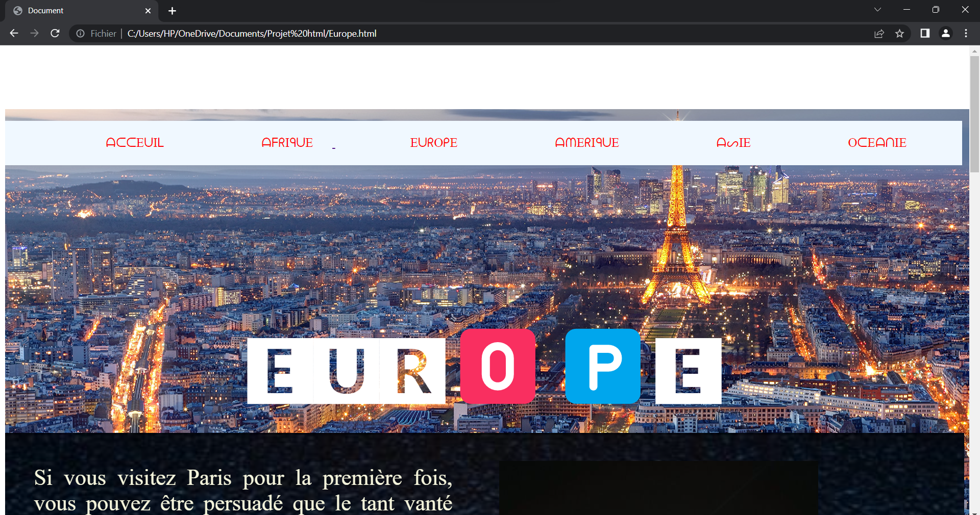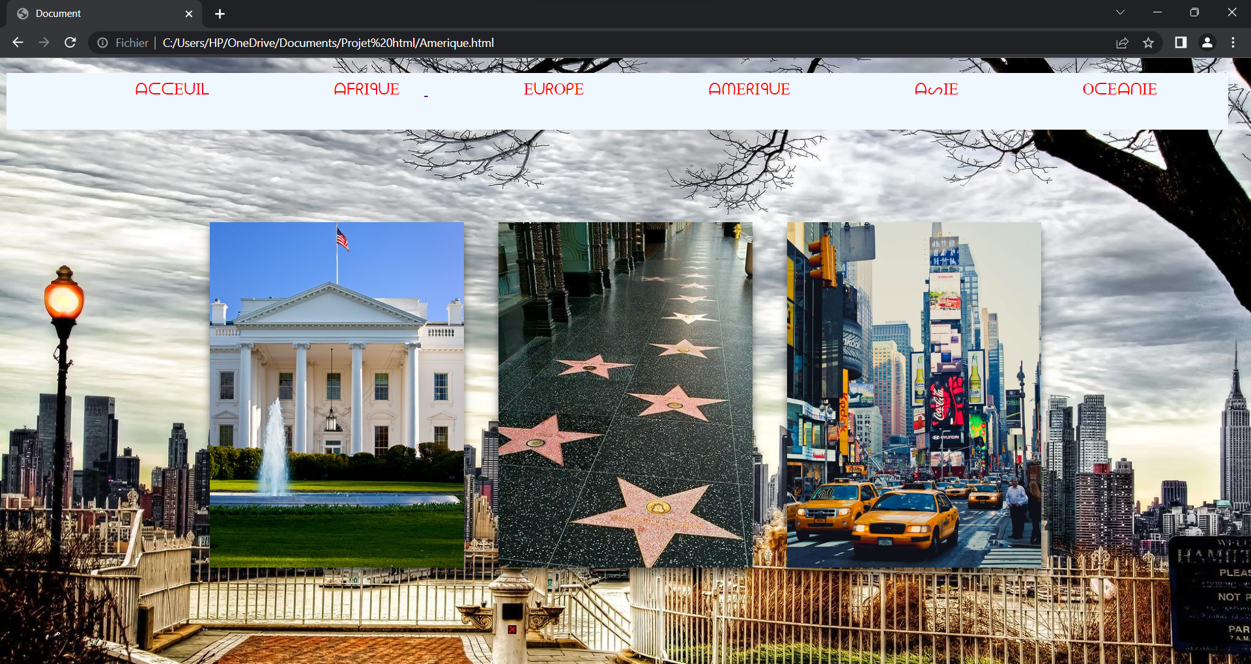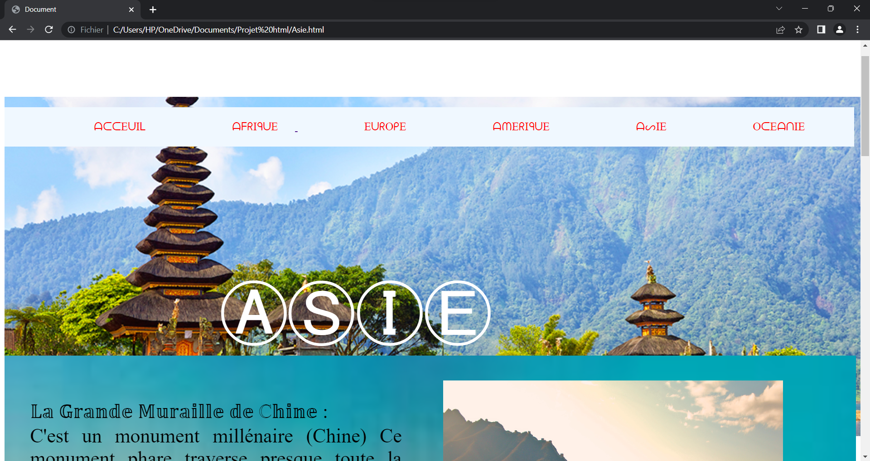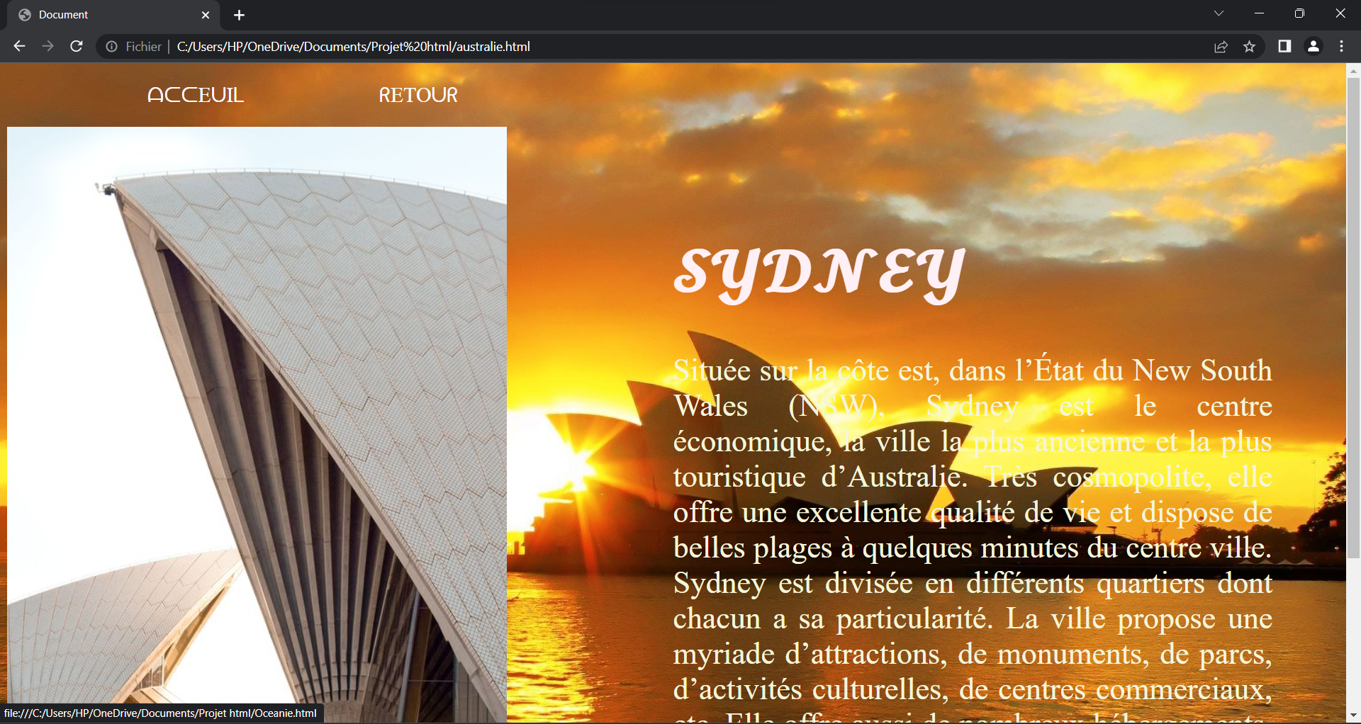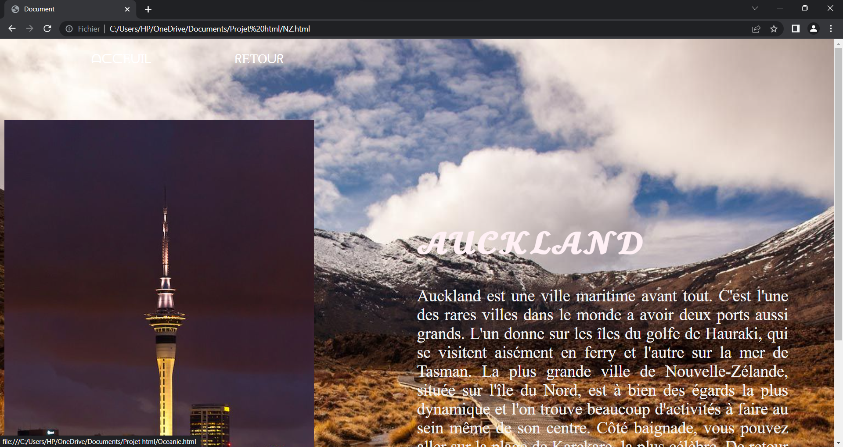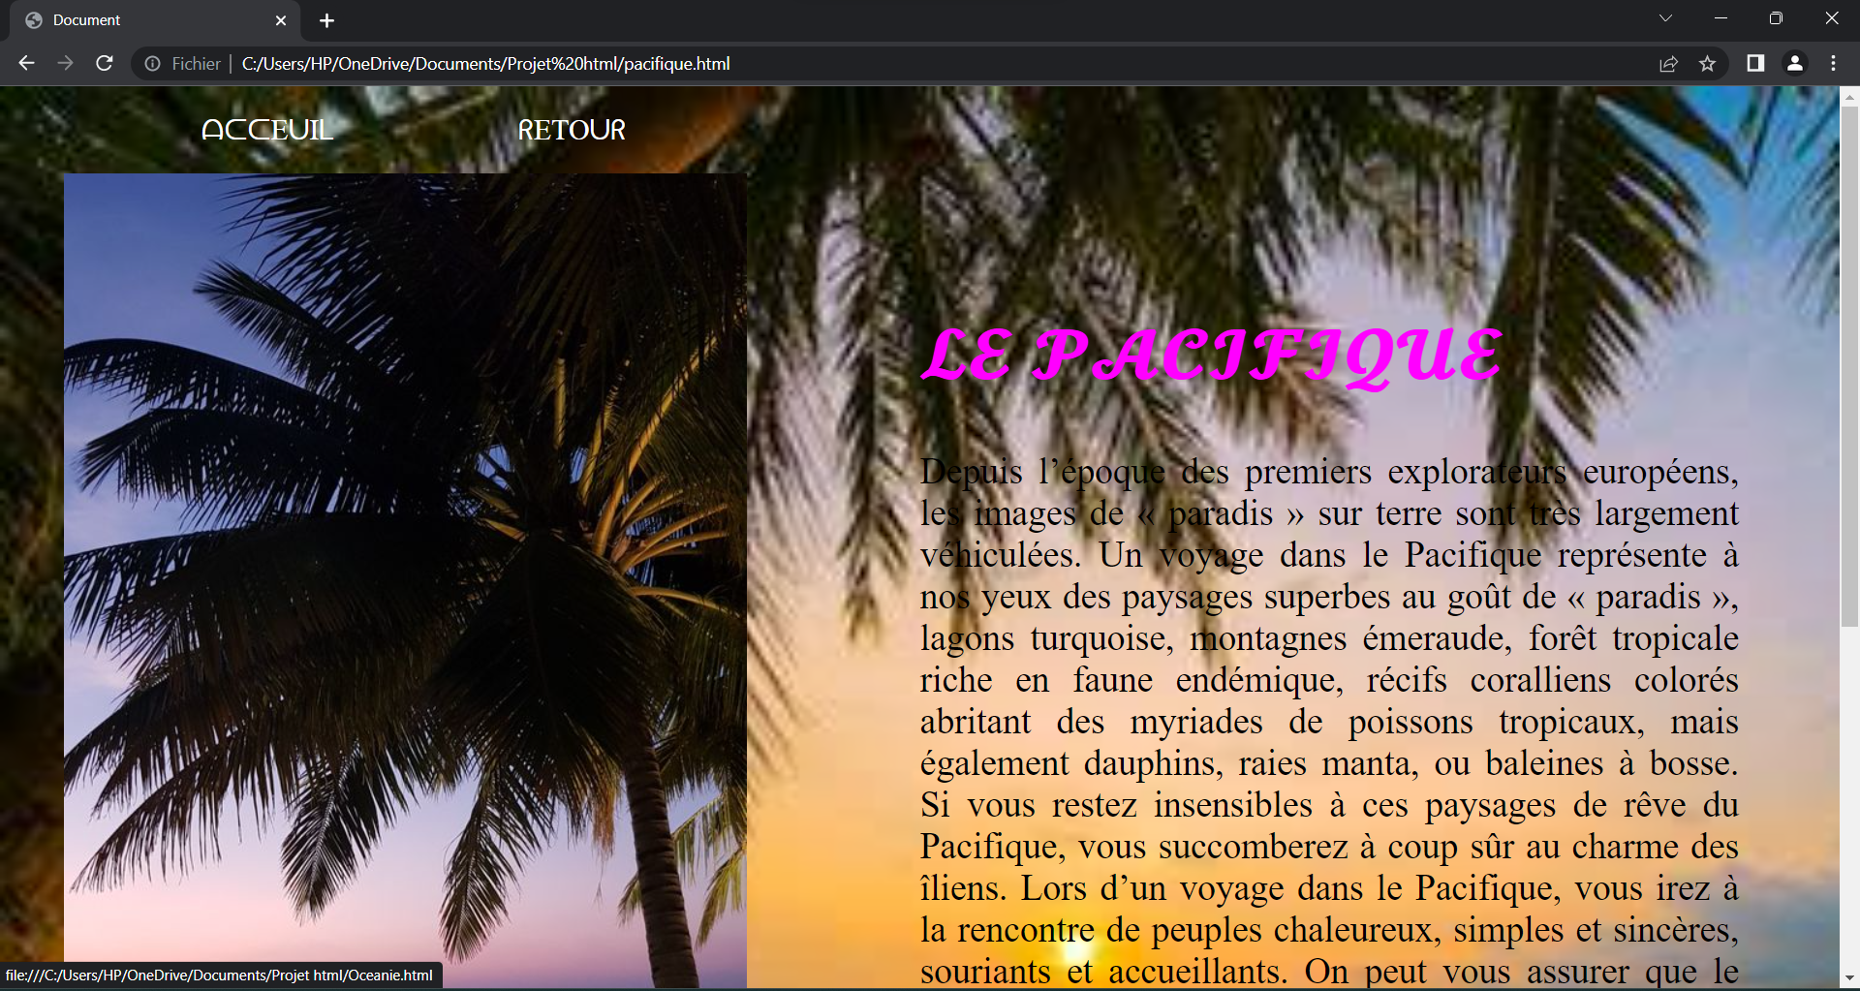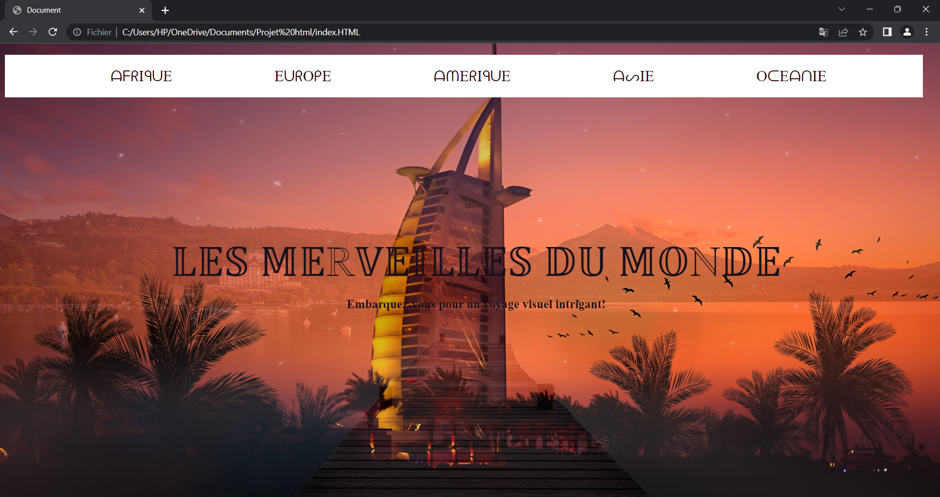

***CONCLUSION***

Ce projet aura été réalisé dans le but de vous présenter les différents sites touristiques que vous pouvez devriez visiter au moins une fois dans votre vie. Se démarquant par la beauté de leurs paysages et leurs histoires ces endroits valent le détour au moins une fois dans la vie.